Title: The cultural evolution of epistemic practices: the case of divination
Author: Ze Hong ^{a1}, Joseph Henrichª
Author Affiliations:
ª Department of Human Evolutionary Biology, Harvard University, 11 Divinity Avenue, 02138, Cambridge, MA, United States
Keywords: cultural Evolution; divination; information transmission; Bayesian reasoning
¹ To whom correspondence should be addressed: ze_hong@g.harvard.edu

Abstract
While a substantial literature in anthropology and comparative religion explores divination across diverse societies and back into history, little research has integrated the older ethnographic and historical work with recent insights on human learning, cultural transmission and cognitive science. Here we present evidence showing that divination practices are often best viewed as an epistemic technology, and formally model the scenarios under which individuals may over-estimate the efficacy of divination that contribute to its cultural omnipresence and historical persistence. We found that strong prior belief, under-reporting of negative evidence, and mis-inferring belief from behavior can all contribute to biased and inaccurate beliefs about the effectiveness of epistemic technologies. We finally suggest how scientific epistemology, as it emerged in the Western societies over the last few centuries, has influenced the importance and cultural centrality of divination practices.

1. Introduction
The ethnographic and historical record suggests that most, and potentially all, human societies have developed techniques, processes or technologies that reveal otherwise hidden or obscure information, often about unknown causes or future events. In historical and contemporary small-scale societies around the globe, divination—"the foretelling of future events or discovery of what is hidden or obscure by supernatural or magical means” –has been extremely common, possibly even universal (Flad 2008; Boyer 2020). Despite this prevalence, the specific methods of divination exhibit substantial variability: what scholars today refer to as “divination” includes inferring meaning from yarrow sticks (I-Ching), deciphering gods’ message from the flight patterns of birds (augury), inquiring about one’s fate through the position of the stars and planets at time of birth (astrology), or identifying the cause of a disease by feeding poison to a chicken (chicken oracle).
For most modern readers, these practices appear striking: they do not seem to be effective ways to generate accurate information or forecasts based on our understanding of the causal structure of reality. Given our confidence in our causal models, we thus confront a puzzle: why do so many divination practices, whose primary goal would appear to be the generation of accurate information, fail so spectacularly to achieve their apparent purpose?
One obvious answer is that people are indeed seeking their explicit goals to obtain accurate information, yet fail to do so because they are making a mistake—they’ve come to believe that certain practices often supply the information they seek but, in fact, their practices are not effective. If true, accounting for the cross-cultural recurrence and historical persistence of divination requires explaining how and why people—and indeed entire populations—would repeatedly make such mistakes. Interestingly, while early positivists held this view of divination practices (Tedlock 2006), modern scholars have sought to contrive all manner of non-instrumental explanations, seemingly to avoid the conclusion that divination practices represent stubborn errors. Common alternative explanations have proposed that divination is a way to (1) claim political legitimacy and power (Flad 2008), (2) reduce anxiety (Kracke 1992), (3) circumvent indecision and resolve disputes (Burkert 1985), or express particular intuitions (Struck 2016). Indeed, the prevalence of non-instrumental explanations in the anthropological and historical literature led Boyer (2020) to quip that divination practices have been explained by, “in short, everything one could think of, except as an attempt to acquire accurate information about some matter of interest.”
It is almost certainly true that divination does indeed have some these effects, but many of these impacts only make sense if people place at least some faith in the divination’s epistemic value. For example, military commanders in ancient Greece could use divination to motivate or manipulate soldiers (Meyer 1925-58); but, the effectiveness of such trickery hinged on the fact that many or most soldiers believed in the validity of the relevant divinatory techniques. Similarly, farmers in late imperial China may have used geomancy (“earth vein”) as a valid legal mechanism to resist the construction of railways by foreign powers (Brown 2017); yet, the fact that this population extensively used geomancy means that its validity was widely acknowledged. In either case, readers should consider how people would react if military generals or courts similarly used divination practices in their societies. Thus, even if these other explanations are relevant in some cases, the task remains to explain why these divination practices are perceived as efficacious in the first place.
This paper will be organized into two parts. In Part 1 (section 2), we present evidence that (a) most divination practices are best viewed as epistemic technologies (tools or methods that people use to reveal hidden information) and (b) people use these technologies in an effort to obtain factually accurate information about their world in order to inform their decisions and actions. People care about the predictive accuracy of these technologies. In Part 2 (section 3), to understand how and why such ineffective epistemic technologies evolve, we develop a formal model to decompose and study the process of belief formation. Our model considers the role of intuitive expectations, personal experience, and two forms of cultural learning (testimony and observation). Using biased or incomplete cultural information can lead to an over-estimation of the efficacy of divination practices in the population, while the heterogeneity in individual beliefs may remain substantial. We also propose an explanation for how many contemporary populations differ from traditional ones, with a focus on epistemic orientations and institutions.

2.1. Divination as technology
Understanding divination as technology has a long history in anthropology. To define “technology”, we employ the dictionary definition “the practical application of knowledge especially in a particular area” (Merriam-Webster), with a focus on the means-end aspect of such knowledge application. Early thinkers such as Edward Tylor and James Frazer unambiguously treat magic (including divination) as false science, or failed attempt to achieve alleged goals. This school of thought was later termed “intellectualism” and remains controversial among anthropologists today. Early ethnographers such as Bronislaw Malinowski and Evans-Pritchard rejected Tylor and Frazer’s stagist view of human societal evolution, but shared the earlier view that magic and divination were instrumental tools aimed at pragmatic goals. (Evans-Pritchard 1937; Malinowski 1955). Later, Horton (1967) expanded on the Tylor-Frazer thesis and forcefully argued that some traditional religious practices in Africa are really efforts to explain, predict, and control worldly events; thus, these practices were not fundamentally different from the approach of Western scientists. The instrumentalist or “intellectualist” view has nearly vanished since then; more recently scholars in anthropology and comparative religion have largely focused on the expressive and symbolic aspect of divination (Geertz 1983; Barley 1983; Akinnaso 1995), while more cognitive minded researchers have focused on the psychology of superstition in contemporary western populations (Rudski 2004; Risen 2016; Vyse 1997)
While an instrumentalist approach likely fails to explain some, and perhaps many, aspects of religion, ritual and magic (Keita 2007), divination practices specifically have a distinctively instrumental flavor. This is because divination—the generation of otherwise unknown information—is rarely an end in itself; the information generated by divination almost always serves as instructions for further action. Divination has several recurrent features that point to its instrumentality as an epistemic technology: it is (1) used for important decisions, (2) costly and often requires a specialist, and (3) approached in ways that only make sense if the actor is actually seeking accurate information.
The first two points are not particularly controversial. Kings and emperors have long used divination to decide when to start a war and with whom to build alliances (Chou 1979). Farmers have used divination to decide where to plant their crops or to figure out why they were sick (Fiskesjö 2017). Performing a divinatory ritual or consulting a diviner can often be rather costly: animal sacrifices, which occasionally involve humans, are frequently needed (Kopytoff 1965; La Fontaine 1959; Akiga, East, and International Institute Of African Languages And Cultures 1939) and the diviners often charge an non-trivial fee for their services (Faulkingham 1971; Beattie 1960; Gulliver 1951; McCulloch 1952).
The third feature is less well appreciated: many recurrent features of divination only make sense when such activities are viewed as attempts to generate true information. Divination practices, for example, often involve repetition to ensure that the revealed information isn’t due to “chance”—like scientific experiments, divinations protocols demand replication to build confidence. Consider five examples:
- In ancient Greece, generals would perform divination procedures multiple times before making important military decisions. As Raphals (2013) points out, if the primary function of divination were to ensure consensus or to boost morale, there would be no incentive to repeat divinatory procedures, at least once the desired response is obtained. This is however the exact opposite of the Greek military practice.
- In early China, while upper level military decisions were made by the state, battlefield divination protocols were frequently repeated to determine and verify the most auspicious dates for military action (Yates 2005).
- In Northern Nigeria during the 1930s, Nupe diviners would sometimes repeat shell throws two or three times to ensure the patterns generated could be replicated, which confirmed the results (Nadel 1954).
- The Tiv had even higher standards in the 1950s: people were only satisfied when at least 4 signs from a “divining chain” were in agreement (Bohannan and Bohannan 1969).
- In South Asia in the 1940s, the Santal people would repeat a “twig-planting” divination procedure to determine the location of a witch. When different verdicts were rendered, suspicions arose that a witch was actively working to conceal their location (Archer 1984).
Besides repetition and the convergence of results, people carefully discriminate among diviners according to perceived skill, ability or success (Beattie 1967; Dyson-Hudson and McCabe 1985; Métraux 1948). As with physicians and auto mechanics in industrialized societies, diviners with better reputations attract more clients and can charge more (McCulloch 1952). If divination was not about obtaining accurate information, why bother to carefully discriminate skill and pay more for popular practitioners? Among the Turkana of east Africa, even laymen could earn a reputation of successfully forecasting the outcome of raids and determining the auspicious occasions, effectively fulfilling the role of a diviner (Gulliver 1951). In other words, diviners are perceived as “skilled” and “unskilled” in pretty much the same way as any other artisans whose abilities can be evaluated by other community members. When raids fail, the Turkana also blame their leaders if the leader failed to heed the results of a divination (Handley and Mathew 2020).
Historically, ancient societies classed divination with other technical skills. In ancient Greece, divination (mantikē) was unambiguously categorized as a kind of technique (technē). Pre-Socratic thinkers such as the Athenian statesman Solon (writing around 600 BC) includes prophecy as a “technē”, along with fishing and farming (Roochnik 2010). The word “technē” historically referred to crafts or skills in general, and it is no coincidence that the modern English term “technology” traces its etymological root to this ancient Greek word. Famously, Plato distinguishes divination into possession divination, where a seer/diviner directly reveals information acquired from a deity, and technical divination (mantikē technē), where the seer/diviner interprets the hidden meaning of natural phenomenon, signs, or portents (Flower 2008). While technical divination clearly delineates some ability or skill rooted in a learned or inherited ability to produce useful outcomes, it has even been suggested that possession divination was considered a technē by the Greeks (Landry 2014; Brickhouse and Smith 2014). Both mantikē and technē serve to produce some desirable or useful outcome, and in this respect an ancient Greek diviner (mantis) who identifies malicious spirits is no different from a modern western physician who diagnoses diseases. Paralleling the ancient Greek usage, the classic “Book of Rites (礼记)” (~206 BC) from early China explicitly lists divination (卜) as a form of art/technique (技), and placed diviners into the same category as scribes, archers, carriage-drivers, doctors, and other artisans.
The relationship between divination and medicine deserves a special mention. Historically, there was significant overlap between divination/magic and more naturalistic healing methods in both ancient Greece and China as well as other prominent early civilizations (L. Raphals 2017; He and Zhang 1994; Van Nuffelen 2014; Sigerist 1951). In many traditional societies, the causes of illness are often identified by divinatory methods (Sigerist 1951; Murdock 1980) in order to determine the best course of treatment; thus, divination is not unlike a blood test. Just as hospital patients care about the diagnostic accuracy of checking their pulse or heartbeat, people in traditional societies care about whether examining the thigh bones from a sacrificed chicken provides the diviner with valuable diagnostic information.

2.2 Divination in southwest China: an ethnographic case
To explore this more deeply, we consider the results of four months of ethnographic research on divination in southwestern China among the Yi in Sichuan and the Wa in Yunnan. Both ethnic groups are small-scale agriculturalists with substantial market integration and access to modern medicine but retain much of their traditional culture. In these populations, a troubled person may consult a diviner for a multitude of reasons, but their primary aim is still to obtain information upon which they could base their action. A person may wish to know the whereabouts of his lost cattle so that he could go find them, the sex of his wife’s unborn child so that he may decide whether or not to abort it, or the identity of the malicious spirit that is causing him illness so that he could provide the appropriate offerings and sacrifices to send it away. For all these practical purposes, villagers always expressed concern about the diagnostic accuracy (准) of local diviners’ predictions and the reputations of different diviners. Though in theory a diviner can reveal all kinds of information, in these populations divination is most often performed to identify the cause of some illness or misfortune.
Interviews with 76 Wa and Yi villagers suggest that they overwhelmingly (96%) believe that certain diviners are “better” than others (for the interview protocol, see Supplemental Information). It is also acceptable to consult multiple diviners to “get a second opinion,” and people frequently make the analogy that consulting multiple diviners is just like seeking advice from multiple doctors (100%, n = 16). When different diviners give the same diagnosis, people feel more confident that the diagnosis is accurate, and thus are more likely to follow the advice regarding which animal to sacrifice (e.g., chicken, pig, etc.). People are also explicit in treating traditional forms of divination and modern medicinal diagnoses as alternatives—a common finding in medical anthropology (Legare and Gelman 2009). Reports from local doctors confirm the instrumentality of illness-related divination; one doctor illustratively said “the primary goal of local health education is to convince people to go to the hospitals first when they get ill,” as the traditional healing processes often result in people going to the doctor at a later and more dangerous stage of their illness – e.g., after an appendicitis has become acute. Many local villagers, however, exhibit a clear preference for modern medical treatments because of its apparent effectiveness (it works) and plausibility (doctors can literally “see” what goes wrong in their bodies through things like CT scans).

In Sichuan province, the Yi even have a second divination procedure to provide corroborating “evidence” (证据) for the first divination. The full process goes like this: in order to determine what animals to sacrifice for a particular illness (which is believed to be caused by spirits), a diviner drops an egg yolk into a bowl with water, stirs the mix, and then reads the pattern of bubbles on the surface to determine the animal to be sacrificed. If the client is skeptical or uncertain about whether the suggested sacrifice will work, he consults another diviner who ritually asks a question of the form, “will sacrificing a chicken (or whatever was stated by the first diviner) appease the spirit?” and then burns the shoulder blade of a sheep to create cracks (Figure 1). This second diviner then reads the cracks to decide whether the chicken sacrifice is likely to do the job. If the signs (the cracks) are auspicious, the client is more likely to proceed with the proposed sacrifice; if the sign is inauspicious, the client must repeat the whole procedure until an auspicious sign appears.
Figure 1. Sheep shoulder blade bone used by the Yi diviners to “verify” whether a proposed animal to sacrifice will “work.”
Both our interviews and many informal ethnographic observations indicate that people believe that divination (and magic more generally) doesn’t always work—meaning that it doesn’t always deliver accurate information. In the illness context, people frequently make the explicit analogy that visiting a traditional diviner/healer is just like going to the medical doctor, and since doctors also occasionally fail to provide an accurate diagnosis (and a cure), it’s unrealistic to expect diviners/healers to get it right every time. To explore this, we straightforwardly asked a sample of 47 Yi adults, “what percentage of the time do you think divination/magic (迷信) works?” The histogram in Figure 2 illustrates the variation in this population. Strikingly, the distribution shows that most people think divination/magic works most of the time. The modal percentage indicates that it works about three quarters of the time, and 83% of participants reported values over 50%. However, there exists significant variation in the responses (mean = 64.25, standard deviation = 26.48) and 9% reported that it never works. Note that people’s responses here do not patterns with their sex, age or level of formal schooling (see the regression analysis in supplemental Table S1).
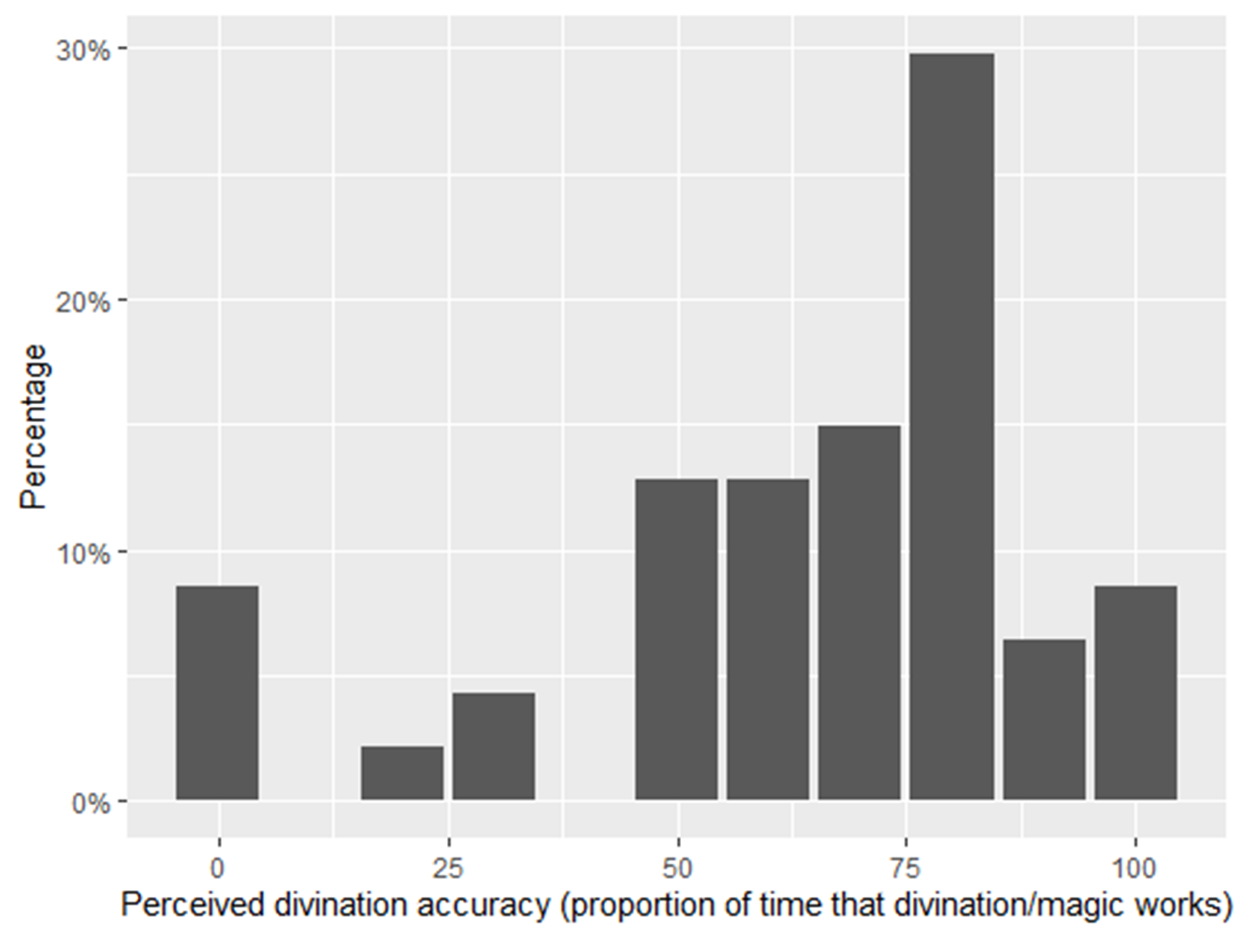
Figure 2. Distribution of perceived accuracy of divination and magic in general. Sample size = 47.
Of course, these percentage should not be taken too literally as people may not be able to fully access or articulate their beliefs in a quantified form (Blanton et al. 2007; Nisbett and Wilson 1977). Nevertheless, it does demonstrate that the majority of people believe that divination/magic often works, but certainly not always. If anything, these reports may be biased downward because both the identity of the interviewer (an ethnic Han speaking Mandarin from the United States) and the simple act of posing such a question, might bias participants towards more skeptical reports.
To summarize, several lines of evidence from diverse societies suggest that people in many populations approach divination as an epistemic technology that they aim to employ to improve their decision-making. This evidence includes responses to direct questions regarding the effectiveness of such technology, implicit behavioral patterns such as repeating or checking divination procedures and looking for converging or confirmatory evidence, and the categorization of diviners with other skilled occupations like artisans.

2.3 Why divination?
Given that divination practices seem unlikely to generate accurate information or diagnosis (unless chicken sacrifices do indeed improve health conditions), we return to our puzzle: why do people believe and perform divination practices? Psychologists and cognitive scientists have tried to answer this question by focusing on the following two aspects:
- What are the recurrent features of divination practices?
- How do such recurrent features contribute to the belief in, or performance of, divination?
Researchers have proposed that the universality and persistence of divination is partly a result of “magical thinking,” which all humans are capable of and is likely a reliably developing feature of human cognition (Nemeroff and Rozin 2010; Gardner and Boyer 1995; Barrett 2004). This type of explanation directly addresses question (a) and indirectly question (b): because humans evolved specific intuitions about the causal structures of the world, certain magical or divinatory rituals simply appear more plausible or believable than others. Cognitive scientists have made much progress in explaining the recurring features of divination and magic in general. For example, Legare & Souza (2012) experimentally show that ritual procedures involving more steps and specific times are regarded as more efficacious; Nemeroff & Rozin (2010, 1986, 1990) argue that people’s susceptibility to contagious magic may confer adaptive benefits as the disgust reaction towards unclean items may contribute to pathogen avoidance ; Singh (2017) suggests that specific aspects of shamanism such as inhumanness culturally evolved as a result of selective retention processes; Boyer (2020) proposes “ostensive detachment” as a feature of divination protocols that makes them appear relatively more credible. In sum, this line of work has successfully attributed many recurring features (e.g. repetition, redundancy, presence of supernatural agents) of technological practices to our evolved causal intuitions regarding what constitute as effective practices.
While contributing to an overall explanation, such evolved intuitions seem unlikely to provide the full story. Consider the naïve Tylor-Frazer re-formulation of the original puzzle: why do such practices exist and persist if they frequently do not obtain the promised results (Tambiah 1990)? In other words, why were these technologies not abandoned as the empirical evidence accumulated, even if only in the experience and lifetime of one person? Tylor himself offers some tentative suggestions, including successful outcome by natural means (chance), vague diagnosis, and an under-appreciation of negative evidence, though he does not endeavor to deliver a definitive theory. This way of framing the question, however, makes it clear that empirical evidence needs to play a role in the evaluation of divination practices, as with any form of technology. This is particularly salient given that many cognitive and evolutionary scientists (1) argue that humans have powerful mechanisms for epistemic vigilance ( Henrich 2009; Mercier 2017; Sperber et al. 2010) that have evolved to protect us from being duped into adopting maladaptive practices or beliefs, and (2) have emphasized the ways in which our cognition updates in an approximately Bayesian (and optimal) manner (Tenenbaum, Griffiths, and Kemp 2006). Indeed, learning from past experience is a fundamental cognitive adaptation that humans share with many other animals (Pearce and Bouton 2001; Rescorla and Holland 1982), and it would be unlikely that people completely ignore empirical evidence when it comes to divination.
Interestingly, to our knowledge, no non-human animals waste valuable resources using divination-like practices to supply information for hunting, attacking other animals or treating illnesses. This point may seem trite, but it highlights the fact that despite our big brains and sophisticated learning abilities, we can still adopt epistemically uninformative practices. One reason why this occurs might be our species’ heavy reliance on cultural learning for acquiring our beliefs (Gervais and Henrich 2010; Gervais, Norenzayan, and Henrich 2011). For humans, empirical evidence consists of more than individuals’ first-hand personal experience. Anecdotes, testimony from others and behavioral observations of others can also serve as important forms of evidence or input into belief formation (Harris et al. 2018; Henrich 2009a; Henrich 2016). Though anthropologists and cultural evolutionists have long pointed out that divination practices are transmitted from generation to generation (Watts et al. 2015), how culturally transmitted information shapes people’s perceptions of technological efficacy has largely been ignored by both anthropologists as well as the mainstream cognitive approaches (with the exception of Souza & Legare (2011)). Much ethnography suggests that information regarding the efficacy of divination is acquired through testimony rather than direct experience (Fodde-Reguer 2014; Singh and Henrich 2020). This is because (1) under uncertainty and especially when costs are high, humans are psychologically predisposed to learn from others (Boyd and Richerson 1985; Laland 2004); (2) many divination practices require substantial expertise and thus non-specialists cannot really “experiment” to check the efficacy of these practices on their own (try doing surgery on your back) and (3) not every individual has the chance to personally consult a diviner to be able to evaluate the predictions. Even in situations where personal experience is involved, the acknowledged uncertainty in divination predictions (people do not expect divination to always generate accurate information) makes a few personal experiences insufficient to reject traditionally accepted claims of predictive accuracy. Occasional failed predictions can be explained away easily, and ethnographic evidence suggests that people readily attribute the predictive failures of divination to technical malfunctions, unfulfilled ritual requirements, or the lack of skill of the diviner (Annus 2010). By contrast, few see divination failures as reason to question their fundamental validity. Importantly, post-hoc rationalizations of divination failure should not be interpreted as people not caring about predictive accuracy. To the contrary, the fact that people feel it necessary to account for predictive failures suggests that they are concerned about such failures and feel compelled to address the outcome (Horton 1993).
Ample work in economics and psychology suggests that despite our cornucopia of decision-making errors and cognitive biases (Korn et al. 2014; Sharot 2011; Joseph Henrich 2002), humans do probabilistically modify their beliefs in adaptive ways as evidence accumulates (Ambuehl and Li 2018; Shah et al. 2016). Belief updating often requires one to integrate information from qualitatively different sources, and research in cultural evolution suggests that humans are “adaptively gullible” (Henrich & McElreath, 2007); i.e. we may have evolved psychological tendencies to heavily rely on social sources, especially when uncertainty is high (Muthukrishna, Morgan, and Henrich 2016). Although social learning strategies evolved to enable individuals to acquire adaptive cultural practices, they can occasionally result in the adoption of maladaptive behaviors (Henrich and McElreath 2003; Richerson and Boyd 2005).
This view is entirely compatible with recent work arguing that humans have cognitive mechanisms supporting “epistemic vigilance” (Mercier 2017; Sperber et al. 2010) including some that evolved to avoid or inhibit manipulation by others (Willard, Henrich, and Norenzayan 2016; Kraft-Todd et al. 2018). Ethnographically, there’s little doubt that epistemic vigilance plays a role in divination: people have always been, often justifiably, worried that diviners may be incompetent, intentionally deceptive, or charlatans. Boyer (2020), for example, points this out, calling it “private doubt,” with ample ethnographic examples (Holbraad 2012; Jackson 1978). However, the existence of such epistemic defense mechanisms does not mean humans reject dubious social information completely—Figure 2 suggests that only 9% of the respondents see divination as always uninformative. A number of cognitive or decision-making mechanisms might promote the persistence of epistemically ineffective practices.
To begin, one obvious reason to not discard a culturally-transmitted but dubious practice might be that if the perceived benefit of acting in accordance with social information is high, then people may behave as if the socially transmitted information is true while remaining rather cognitively skeptical. This is effectively a rational choice version of error management theory (Haselton and Buss 2000; D. D. P. Johnson et al. 2013; McKay and Efferson 2010), where individuals maximize expected utility given a set of probabilistic beliefs. A person suffering from some illness may consult a diviner, hoping that the diviner may be able to offer the correct diagnosis which presumably could lead to the correct treatment. The patient here does not need to be certain about the predictive accuracy of the diviner; in fact he can be quite skeptical, but because the potential benefit of recovering as a result of the diviner offering the correct diagnosis is much more than the cost (payment to the diviner and possibly some sacrificed animals), he is willing to give it a try. This type of situation probably happens frequently in modern medical settings: when conventional treatment fails, many people are willing to try alternative medicine and healing methods even though they may be quite skeptical of their efficacy -- otherwise they would have used such alternative treatments first (Vohra et al. 2005; Kantor 2009).
Second, for a naïve observer assessing the efficacy of a particular divination practice, a useful source of information comes from observing the costly actions of other people. Noting that other older and more successful people consult diviners may lead learners to infer that others really believe in the efficacy of divination. If they update their beliefs accordingly and sufficiently, a positive feedback loop may be created that, operating recursively over generations, could inflate efficacy estimation. Such a phenomenon could result from one of the first mechanisms of epistemic vigilance to be proposed: Henrich (2009) argues that learners should rely on “CRedibility-Enhancing Displays” (CREDs) to avoid being duped or manipulated. The idea here is that learners should be more likely to acquire the beliefs of others when those others perform costly action that they would only perform if they truly hold their stated beliefs: hearing an esteemed members of one’s community extoll the importance of using divination to fight illness is a lot more persuasive if those same individuals also pay diviners for rituals when they are ill. A growing body of empirical work supports this hypothesis (Kraft-Todd et al. 2018; Cho et al. 2012), including work among shamans (Singh and Henrich 2020).
Behaving optimally in the presence of different information sources can be difficult. Indeed, even pure Bayesians can sometimes end up with sub-optimal behavior in certain situations. For example, when individuals can observe others’ behavior and make their own decisions in a sequential manner, the first few individuals’ decisions may heavily influence later decision makers to the extent that they sometimes completely ignore their private signal and behave sub-optimally. Such “informational cascades” or “herding” have been extensively discussed in economics (Banerjee 1992; Bikhchandani, Hirshleifer, and Welch 1992) and find ample empirical support (Kim et al. 2004; Duan, Gu, and Whinston 2009; Lohmann 1994). In reality, humans are unlikely to carry out the exact Bayesian computations and therefore imperfect inferences should occur rather often.

3. Modeling the transmission of epistemic practices
In today’s anthropological literature on divination there seems to be an implicit assumption that because divination is not objectively effective, it cannot be the case that people are striving to obtain more accurate information about the world. This narrative logic ignores the fact it is ultimately the subjectively perceived efficacy that matters (Singh 2017), and objective efficacy is not the only factor that contributes to subjective perception. People’s final evaluation of the efficacy of divination (or any technological practice), though mediated by the processing of information from different sources, ultimately has objective efficacy as one important input (Fig 3). In Section 1, we have provided ample evidence for the instrumental nature of divination, which begs the question of its persistence; in Section 2, we have reviewed the existing literature in psychology and cognitive science on the psychological factors that sustain ineffective technologies as well as the importance of cultural learning in belief formation. In this section, we take a formal modeling approach to take into account both the dominating view that the persistence of these ineffective technologies is primarily the result of our evolved intuitions and our proposed learning component in belief updating by tracking individuals’ belief in the efficacy of some epistemic technology in a dynamic setting. In doing so, we provide a more rigorous analysis of how different types of information (evolved intuitions, testimony, and observation of other’s actions) contribute to people’s belief and confidence in the efficacy of some technology.
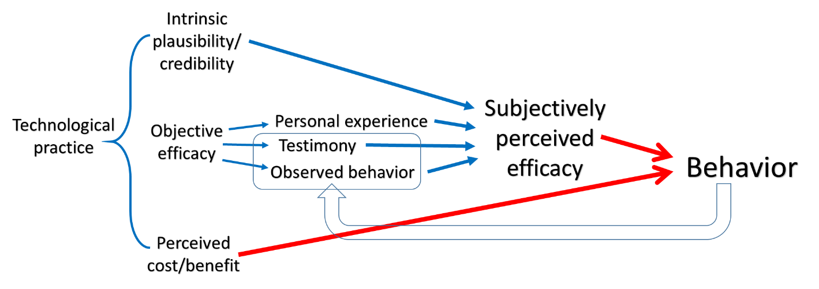
Figure 3. Causal diagrams of factors that affect subjectively perceived efficacy. The three components of a given technological practice (intuitive plausibility/credibility, objective efficacy, perceived cost/benefit) are listed on the left side after the curly bracket; causal relationships that contribute to subjectively perceived efficacy are represented by blue arrows, and causal relationships that contribute to behavior (whether to engage in the technological practice or not) are represented by red arrows. The feedback occurs when one individual’s behavior becomes other naïve individuals’ observations which may be affected by reporting and inferential biases (hollow blue arrow).
Figure 3 shows that divination, or any technological practice can be perceived as efficacious due to either its intuitive plausibility or objective efficacy. In reality, however, both factors are likely at play. As mentioned earlier, much work has been done to examine the relationship between intuitive plausibility and subjectively perceived efficacy. What is notable about objective efficacy is that it does not manifest itself directly, rather it contributes to subjectively perceived efficacy via various epistemic routes: via personal experience, testimony, observed behavior, etc. Crucially, such epistemic routes do not always guarantee the accurate translation of objective efficacy into subjectively perceived efficacy. In the model, we integrate these different sources of information to analyze how beliefs are updated and when individuals might systematically overestimate the effectiveness of different technologies. We also consider how these beliefs then impact decision-making and behavior, given people’s perceived costs and benefits of potential outcomes. In our model, people’s behavior is then observed by others in the community who then use these observations to update their own evaluation of the efficacy of the technology, initiating sequential belief and behavior change at the population level—that is, cultural evolution.

3.1. Model description
Here, we provide only a verbal description of our model, leaving the mathematical details to the Supplemental Information (SI). In the model, individuals’ belief in some technological practice ($Δ$) is represented by a beta distribution with parameters $α$ and $β$ that can be updated from various social information sources in a Bayesian fashion. Here $α$ and $β$ denote the relative amount of positive and negative evidence for/or against the efficacy of $Δ$. Larger $α$ relative to $β$ thus means a strong belief in $Δ$’s efficacy. The mean (expectation) of beta ($α$,$β$) is $\frac{α}{α+β}$ and can be roughly viewed as a subjective estimation of the proportion of time that $Δ$ yields positive outcome. Importantly, individuals do not distinguish real effectiveness and chance; that is, individuals do not actively try to figure out whether some technological practice performs better than chance. We feel that this is a reasonable assumption as problems routinely solve themselves (e.g. regression to the mean or placebo effect) and individuals are much more likely to focus on cognitively salient events (e.g. divination) that occur prior.
An individual always starts with beta (${α=α}_{0}, { β=β}_{0}$), where $α_{0}$ and $β_{0}$ are the prior belief of an individual which represent her confidence in the efficacy of $Δ$ in the absence of data. Strong, biased priors could result either because humans have evolved psychological intuitions (Nemeroff and Rozin 2010) or because they fit better with existing beliefs in some cognitive sense (Henrich and McElreath 2003). A person’s $α$ and $β$ values then gradually change as she acquires relevant information from three sources (1) personal experience, (2) the testimony of others (positive/negative outcome of $Δ$ reported) and (3) the observed actions of others (practicing $Δ$). In deciding whether to perform $Δ$, an individual will sample from her belief distribution and perform $Δ$ if the expected benefit b is larger than the cost c ($p_{sampled}*b>c$). This is simply a formal way of saying that people who are more confident in the efficacy of $Δ$ are more likely to practice $Δ$ while taking costs and benefits into consideration.
Since we are describing individuals’ beliefs probabilistically, the primary aim of this model is thus to examine the conditions under which people’s subjectively perceived efficacies deviate from the objective frequency and the associated behavioral outcomes. We are especially interested in any condition that might generate subjectively perceived efficacy greater than the true efficacy (denoted by r, often chance in the case of divination), because such over-estimation could result in costly and ineffective information seeking behaviors like divination.
To fully explore the cultural evolutionary dynamics produced by these individual-level processes of belief updating, we constructed an agent-based simulation. Each individual agent in the first generation encounters a situation in which they need to decide whether to perform a technological action or not based on their belief about the efficacy of the technology and a cost-benefit calculation. Agents in the next generation update their belief regarding the efficacy of the technology using the observed behavior and the associated outcomes from a subset of agents in the previous generation (cultural models), and then further update their beliefs using personal experience. As such, the number of different types of information instances is determined by the dynamics of the system, and we examine the parameters that affect the distribution of individual agents’ beliefs at equilibrium (i.e. when the belief distributions of the populations become relatively stable over time).
It is worth noting that although in our simulation agents update their belief in a Bayesian way, the insights that our model generate does not depend on pure Bayesian reasoning. In fact, as long as people update their beliefs that qualitatively resembles Bayesian updating (i.e. increase belief estimate as positive information comes in and decrease belief estimate as negative information comes in) they may end up with biased estimation of the efficacy of these technologies.

3.1.1. Simulation results
We ran many simulations to examine the relationship between agents’ belief distribution and various parameter combinations. See supplemental Table S2 for a list of the parameters used in the simulation. We will first present the distribution of agents’ mean belief ($\frac{α}{α+β}$) for the entire population at equilibrium states by varying a few key parameters, then focus on the population average belief levels and further explore the parameter space in a combinatorial fashion.

3.1.2. STRONG INTUITIONS? THE IMPACT OF PRIORS
As mentioned, the a priori plausibility of epistemic practices could contribute to subjectively perceived efficacy. In a Bayesian context, such plausibility translates into non-flat priors. Fig 4 shows the distribution of individual mean beliefs at equilibrium. This result is consistent with our intuition: large $α_{0}$ values shift agents’ belief distribution towards 1, meaning agents are more likely to believe in the efficacy of technology $Δ$. Aside from setting the initial belief conditions to get Bayesian updating going, priors in our simulation play a special role: they prevent individual’s beliefs from converging. This is because each generation of naïve individuals starts anew with the innate or intuitive prior, which mean that they have to re-acquire information from various sources. In other words, such “reassertion of the prior” every generation makes empirical experience insufficient to overwhelm the influence of priors, meaning that generations of individuals may always have substantial confidence in the efficacy of some epistemic practice due to its intuitive appeal.
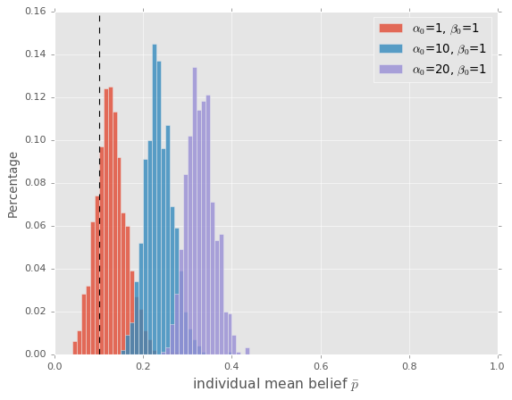
Figure 4. The distribution of individual mean belief under different prior belief conditions. Mean of the above distributions: 0.11 ($α_{0}$ = 1), 0.22 ($α_{0}$ = 10) and 0.34 ($α_{0}$ = 20). Other parameter values: $b=5$, $c=1, θ=0.0$. Dashed line represents the true efficacy of the technology (r = 0.1).

3.1.3. UNDER-REPORTING OF NEGATIVE EVIDENCE:
As mentioned, instances where epistemic practices fail to yield accurate information may be under-reported. Such under-reporting could result from multiple factors. First, a rich literature in psychology on “confirmation bias” suggests that people have a tendency to selectively interpret, favor, or recall information that confirms their existing beliefs (Nickerson 1998; D. K. Johnson 2017). Predictive failures, therefore, may be overlooked because they contradict people’s priors. Second, because epistemic technologies (or any technologies for that matter) often require skills and have reputational consequences, diviners themselves may be more willing to advertise their success stories as they serve as a signal of competence. Finally, the literature on norm psychology suggests that one of the most fundamental human psychological tendencies is to observe, internalize, and follow rules (Chudek and Henrich 2011; Schmidt et al. 2016), and in societies where divinatory practices are the dominant method of generating information, revealing negative results may be viewed as a norm violation, as doing so would suggest the individual doubts the validity of such divinatory practice. From a historical perspective, the Chinese textual record shows that there likely exists significant under-reporting of failed predictions of divination as well as failed attempts in magical practices such as rainmaking and dream divination (Hong, submitted).
Figure 5 shows the distribution of individuals’ mean belief under different degrees of under-reporting bias. Here $θ$ represents the proportion of negative outcomes that is unreported. When no bias exists ($θ$ = 0.0) and people report in proportion to the true rates, the distribution of individuals’ beliefs (red) ends up much closer to the true efficacy (dotted vertical line) compare to when such some bias is present (blue and purple, 30% and 60% negative cases not revealed respectively).
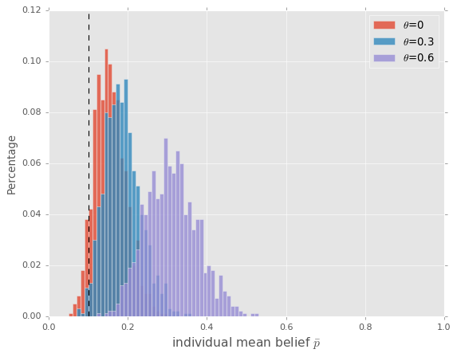
Figure 5. The distribution of individual mean belief under different under-reporting conditions. Mean of the above distributions: 0.26 ($θ$ = 0.13), 0.19 ($θ$ = 0.0) and 0.32 ($θ$ = 0.0). Other parameter values: $α=β=1$, $b=5$, $c=1$. Dashed line represents the true efficacy of the technology (r = 0.1).

3.1.4. MIS-INFERRING/UPDATING BELIEF FROM OBSERVED BEHAVIOR
Inferring other individual’s belief based on their behavior is non-trivial and using such observation to update one’s belief correctly may be very difficult. This is because when we take the cost/benefit into consideration, the relationship between belief and behavior is not one-to-one. In our simulation, individuals sample a belief from his belief distribution ($p_{sampled}$) and use it to make cost/benefit calculations. Recall we have shown that action will occur when
$$p_{sampled}*b>c$$
where $p_{sampled}$ is a single value sampled from an individual’s beta distribution regarding the efficacy of technology $Δ$. Re-arranging the equation, we have
$$p_{sampled}>\frac{c}{b}$$
Because using the epistemic practice $Δ$ is a dichotomous action (one either performs the divination practice or not), the relationship between agents’ belief and action is a piecewise function, which means the same action/inaction can be the result of a wide range of belief values. Figure 6 shows heatmaps representing the relationship between agents’ belief distribution parameters ($α,β$) and the expected proportion of times agents perform the action under various cost/benefit ratios. Notice that different $α$ and $β$ values often lead to similar frequencies of action performed. When the perceived benefit is larger than the cost ($\frac{b}{c}=10$ and 5 respectively in Figure 6), the majority of beliefs corresponds to high percentage of “action” decisions, and therefore it would be difficult for naïve agents to correctly infer individuals’ underlying belief distribution from observed behavior. So, high $\frac{b}{c}$ ratios can conceal valuable information.
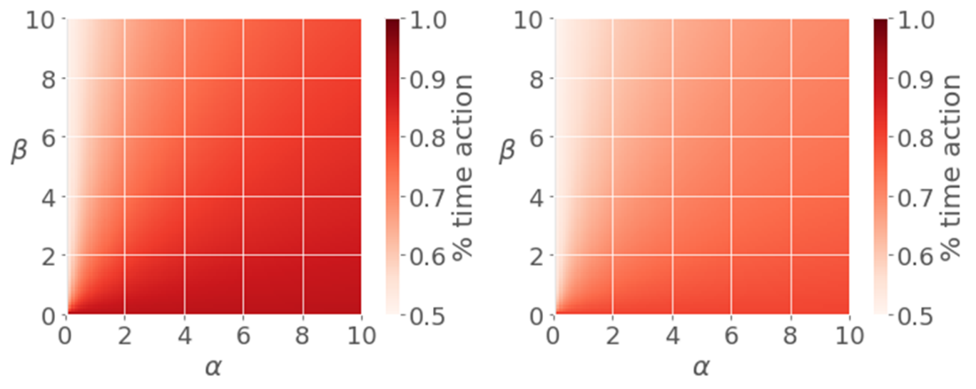
Figure 6. The relationship between belief distribution parameters ($α$ and $β$) and the proportion of times agents perform the action (represented by color intensity) under two different cost/benefit scenarios (left: $\frac{b}{c}=10$; right: $\frac{b}{c}=5$).
Figure 7 shows the distribution of individual mean beliefs under different cost/benefit ratio conditions. When the perceived benefit is relatively low, agents are less likely to believe in the efficacy of technology $Δ$ compared to when perceived benefit is high. This is largely because only a small proportion of the agents in the populations are still performing the action (action rate = 0.11) and therefore agents in the next generation take such inaction as evidence against $Δ$’s efficacy. In contrast, when perceived benefit is very high, almost all individuals perform the action, which, when the epistemic weight on observed action is large, increases individuals’ estimation of $Δ$’s efficacy.

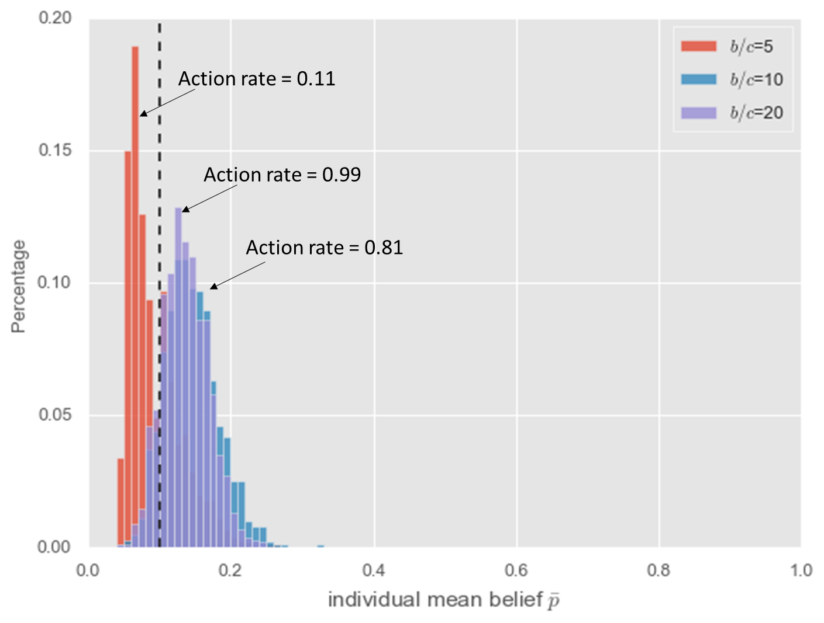
Figure 7. The distribution of individual mean belief under different cost/benefit conditions. Action rate refers to the proportion of agents who performed $Δ$ in the last step (personal experience) of their life cycle. Mean of the above distributions: 0.092 (b/c=5), 0.145 (b/c=10) and 0.136 (b/c=20). Other parameter values: $α=β=1$, $θ=0.0$. Dashed line represents the true efficacy of technology (r = 0.1).
Finally, we present a more extensive exploration of the parameter space (Fig. 8). Here, $w_{o}$ denotes the epistemic weight of observed action. The error bars indicate that our simulation results are robust, and the results here are consistent with what has already been presented. Nevertheless, visualizing the influence of multiple parameters simultaneously yields some additional insight. Notice that while the contribution of the epistemic weight of observed action ($w_{o})$ is positive when the perceived benefit of performing the action is large, $w_{o}$ is negatively correlated with the efficacy estimate when perceived benefit is low. The left panel of Figure 10 (b/c = 1) is an extreme scenario: when the cost of performing the action and the perceived benefit is the same, no individual will perform the action because while the cost is certain the benefit is probabilistic; therefore, $p_{sampled}$ is always smaller than b/c, or 1. Large weight on observed action $w_{o}$will thus decrease individuals’ confidence that $Δ$ is efficacious.
It is also worth pointing out how priors may interact with other parameters. Reassuringly, in all conditions stronger priors (large $α_{0}/β_{0})$ leads to higher efficacy estimate; however, even in cases where individuals may be skeptical of the technological practice ($α_{0}/β_{0}=0.1)$, they may still end up estimating its efficacy above its real value (r = 0.1). This is especially true when perceived benefit and the epistemic weight on observed action is large.
One implication of this finding is that it may not be necessary to invoke “evolved psychology” favoring certain kinds of content to explain people’s belief in seemingly counter-intuitive divinatory practices (Boyer 2020). People in traditional societies may find some practices as odd as modern people do; it’s just that the cultural information pre-modern people receive trumps their intuition. Indeed, Margaret Mead (1932) showed that among the Manus in Papua New Guinea, it was the adults rather than the children who were more prone to magical thinking and supernatural beliefs. More recently, Harris (2012) suggests that people in certain religious societies may even be described as “shedding Enlightenment and moving toward magical thinking” as a result of cultural transmission. Ample developmental research has shown that children acquire a significant amount of information from asking questions (Frazier, Gelman, and Wellman 2009; Chouinard 2007) and heavily rely on what they are told especially from familiar individuals (Corriveau et al. 2009; Harris et al. 2006) as children are often not in a epistemic position to evaluate the validity of culturally transmitted claims .
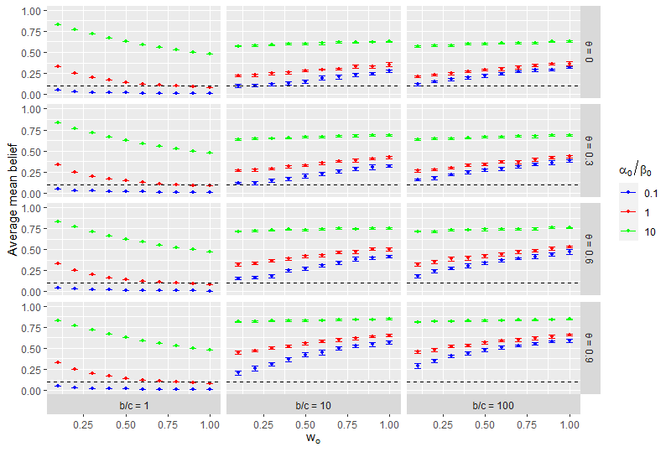
Figure 8. Exploration of parameter space in a combinatorial fashion. Each data point represents the population average of individual mean belief at equilibrium for a given parameter combination. Error bars represents 95% confidence interval for 10 independent simulation runs. Values of unspecified parameters are as in table 2. Horizontal dashed lines represent the true efficacy of technology (r = 0.1)
Our simulation has shown that a few factors, including strong priors, the under-reporting of negative evidence and high perceived benefit to cost ratios combined with the epistemic weight attached to observed actions could all bias individuals to over-estimate $Δ$’s efficacy. People are most likely to believe in the efficacy of some technology when it is intuitively plausible, its negative instance under-reported, and its perceived benefit large, particularly in communities where people heavily rely on observed behavior to infer efficacy. In reality, these factors may all co-exist which could push the deviation between individuals’ subjective belief and the true efficacy quite large. We emphasize that although biased priors, which have been extensively discussed in the psychological and cognitive science literature, may certainly contribute to our biased belief, social and cultural factors, in particular the generation and transmission of cultural information, may also play important roles in affecting our evaluation of the efficacy of technologies.

4. Discussion
We have presented converging lines of evidence showing that many forms of divination can be and should be viewed as technological practices, and given that people often have a probabilistic understanding of their efficacy, a combination of biases could generate excessive confidence in the effectiveness of these practices at the population level. Below we discuss the relationship between divination some early modern epistemic practices in the West, the interplay between evolved intuition and cultural transmission in maintaining ineffective technologies, and some comments on the evolution of divinatory practices as societies transition towards epistemic modernity.

4.1. Divination: just like any other technological practice?
Many authors have pointed out that viewing divination as a method or device to generate information is not qualitatively different from other types of ordinary technology. In her book, Ancient Greek Divination, Sarah Johnston (2009) points out
The good diviner knew about the sympathetic links between, say, the appearance of a night-owl during the day and political insurrection and could therefore predict what was going to happen when such a bird showed up. But this prompted such questions as how we should distinguish between the art of the diviner and the art of the doctor, the farmer, the sailor or anyone else who made it his business to learn how one thing signified another that was yet to come – is it divination to know that an olive crop will be abundant by looking at blooms early in the season, or is that just good arboriculture? Is it divination to predict rain by looking at a dark cloud, or is that simply the sort of practical meteorology that every reasonably intelligent person picks up during the course of life? (p. 5)
What Johnston suggests here is that it may be difficult to classify divination as a special kind of activity which is fundamentally different from everyday means-end practices in any definitive way. Furthermore, what contemporary researchers refer to as divination was also often part of the general epistemic effort to identify regularities in the world. Indeed, what was viewed as legitimate ways of producing knowledge in one historical period could be considered divination (or pseudo-science) in a later time (Thagard 1978): both astrology and physiognomy have suffered from this fate. Note that the historical development of astrology has always been linked with astronomy which nobody today would deny as a legitimate science. In many early civilizations such as those in ancient Greece, Babylon, and China, astronomers and astrologers were the very same people (Rochberg 2004; Pankenier 2011; Huber and Swerdlow 2001). In fact, the goal of astronomy was often to inform practical astrological applications (Nakayama 1966). This was even true for some of the great early modern thinkers: both Johannes Kepler and Isaac Newton were interested in astrology (Field 1984; Boner 2008; Force and Popkin 1999); Kepler’s fascination with astrology even led him to personally produce over 800 horoscopes (North and Hoskin 1995).
Physiognomy has a similar story. In many ancient civilizations, physiognomy, or the study of the correspondence between facial/physical features and psychological characteristics constituted much of their practical philosophy. Influential thinkers such as Aristotle wrote extensively on physiognomy primarily on the resemblance of humans and animals regarding certain characteristics; for example, a person with a large (ox-like) forehead is sluggish (L. A. Raphals 2013), which in cognitive scientific terms would be a kind of similarity-based induction (Weber and Osherson 2010; Heit 1997). Throughout Western intellectual history the study of physiognomy has long been regarded as a valid science with a sound theoretical basis despite occasional skeptics (Ziegler 2007). Physiognomy’s younger brother, phrenology, also played a significant role in early studies in psychology and anthropology as late as the 19th century (Staum 1995; Greenblatt 1995). To be fair, the meta-idea that physical traits may be correlated with psychological ones is not totally implausible even by today’s standards; behavioral and anatomical phenotypes could share an underlying genetic basis and therefore could be correlated. For example, individuals with Down syndrome have very characteristic physical appearances that are often accompanied by cognitive deficiencies and distinct behavioral patterns (Patterson 1987).

4.2. Why divination? Evolved intuitions and cultural transmission
This paper has emphasized the role of adaptive learning mechanisms in shaping individuals’ beliefs and technological behavior at the population level. Of course, this is not to deny the importance of content-specific evolved intuitions; as mentioned, they likely contribute to our priors in the belief-updating process. The “priors” in the model ($α_{0}/β_{0}$) refer to both the evolved and transmitted or developed intuitions. In other words, the “priors” need not be specific evolved psychological tendencies; they could also be culturally transmitted worldviews or meta-understandings of the causal structure of reality. With such priors, belief updating based on information from different sources takes place. In this paper, we asked if such updating, even if incoming information is optimally processed, always produces the correct belief regarding the efficacy of various technological practices. We have provided a theoretical framework to illustrate that subjectively perceived efficacy can be different from objective efficacy, and presented a few scenarios where both biases (e.g. under-reporting of negative evidence) as well as learning and decision-making dynamics (e.g. mis-inferring belief from behavior in the presence of cost/benefit analysis) can lead to an overestimation of the efficacy. Across historical/cultural space and time, humans everywhere have been empiricists, in the sense that they incorporate sensory data obtained from their experience into their belief and subsequent decision-making. These data are often not sufficient or even available, in which case we necessarily have to rely on socially transmitted information which itself may be occasionally inaccurate.
In a Bayesian framework, the relative weight of different information sources becomes the key in determining the eventual belief updating outcome. Do humans weigh personal experience more than anecdotal stories or observed behavior? What are the types of mental calculations when different sources provide conflicting information? These are important, open empirical questions that should be addressed in the future. We suggest that significant cultural variations on these epistemic weights may exist. Most notably, post-enlightenment societies have undergone a profound epistemic transition towards an emphasis on experience over transmitted wisdom (Wootton 2016; Strevens 2020), and such a transition may have induced a cascade of institutional and psychological changes regarding what individuals consider as legitimate ways of generating genuine knowledge (Henrich 2020).

4.3. Modernity, science and the evolution of epistemic norms
Modern societies differ from traditional societies in many ways. Here we use the words “modern” and traditional” to refer to differences in individual epistemic orientations (preferred ways of accessing and evaluating knowledge) and in societal epistemic institutions. We argue that two crucial differences explain why people in modern societies are able to obtain relatively more accurate beliefs. First, technology, science and western-style education that emphasizes a materialistic worldview produce a different kind of “prior” in post-enlightenment, contemporary societies. A person who lives in such societies does not need data to be deeply suspicious of the claim that illnesses can be diagnosed by examining the holes from chicken thigh bones and be cured by sacrificing domesticated animals to appease the spirit; our metaphysical theory about causality is mechanical and materialistic, and it actively denies the causal relevance between events that do not have plausible physical connection. Second, modern societies have a larger division of labor in knowledge transmission: scientists as the producers of knowledge and lay people as the consumers of knowledge. Scientists value personal experience and anecdotal experience but they do so in a systematized way: personal experience becomes randomized, controlled trials and anecdotal stories become meta-reviews and meta-analysis which largely avoids the under-reporting of negative evidence and other biases. Additionally, many lay people in such science-reliant cultures also develop a sense of how knowledge should be reliably generated; for example, one does not need to be a scientist to know that evaluation of the efficacy of drugs requires randomized, controlled trials (minimally, some kind of experimentation), or that a neighbor’s anecdotal story of her horoscope correctly predicting her personality does not qualify as evidence for the validity of astrology. In this way, scientists are able to generate accurate information and lay people, by de-valuing personal experience and anecdotal stories, heavily weigh information from scientists (who are the epistemic authorities) and thus acquire relatively more accurate beliefs and effective technologies.
Given the profound difference between modern and traditional societies in this epistemic aspect, it may be useful and informative to dig deeper and examine the historical context in which such epistemic transition happened. Historians of science have been arguing over whether there was such a thing as the “Scientific Revolution” (Shapin 2018; Beale and Hall 1956; Keller, Lindberg, and Westman 1993), and there has been no lack of speculation regarding why the rise of empirical science occurred in Europe (V. Singh 1987; Sivan 1985). Yet, whatever the initial cause, few would deny that their spectacular scientific and technological developments gave the Europeans a definitive advantage in their interaction with other societies. We suggest that the spread of scientific institutions and experimental methods may be viewed as an example of cultural group selection (Richerson et al. 2016). On the one hand, the products of science, such as military technologies undoubtedly contributed to the success of Europeans in conquering other groups, after which European cultural practices diffused to these groups through colonization and prestige-biased transmission (Henrich, Boyd, and Richerson 2012). On the other hand, the realization of the superiority of modern science and technology also prompted non-European societies to adopt both practical technologies and the scientific institutions that generate such technologies. Below, we examine two historical cases (Japan and China) with some details of how such transitions occurred. Both nations were exposed to western military technology during the mid-19th century (Hones and Endo 2006; Cheng and Waley 1960) and were overwhelmed by its technological superiority. The scholar of the late Edo period Sakuma Shozan famously proposed “Eastern ethics, Western science” (Van Sant 2004) and in the subsequent Meiji restoration more substantial westernization occurred, including the establishment of western style scientific and educational institutions (Bartholomew 1989). Many traditional cultural practices and beliefs were labeled superstitious (迷信/めいしん) and some were banned at the legislative level (Figal 1999). The Qing dynasty of China initially focused on adopting western military technology as the ruling class and the literati attributed losing the First Opium War solely to the superior ships and cannons (船坚炮利) of the British Navy (Cheng and Waley 1960), but later also established western-style schools and set up programs to send promising Chinese students to Europe and the US for higher education almost exclusively in applied science and technology (Deng 1995; Xiu-li 2008). The Qing dynasty however did not last long and was overthrown in 1911 (Gao, Zhang, and Tian 2015). Soon after this, in 1919 there was a massive political-cultural movement (known as the May Fourth Movement) that deemed the fundamental source of China’s weakness as traditional value systems and culture in general; leaders of this movement proposed a categorical rejection of almost everything traditional, and strongly espoused western ideals of democracy and science (Spence 1982) as well as kinship and marriage institutions such as normative monogamy, bilateral inheritance and prohibitions on arranged marriages (Henrich 2020). During the Republic of China period (1912-1949), divination, along with a range of other traditional cultural practices came to be viewed as irrational superstitions that should be eradicated (Zhiwei 2009). Note that both countries have sustained various kinds of divination and magic practices for millennia; it can be very difficult for societies to epistemically modernize on its own and such modernization often require external influences at the group level.
From critical reliance to marginalization, the substantial decline of divination in many parts of the world cannot be fully explained without considering the diffusion of western science and the epistemic culture it fosters. To reiterate, the technological nature of divination practices means that it suffers in the presence of science on two fronts: (1) divination loses its intrinsic plausibility and (2) the efficacy of divination practices does not survive systematic scientific examination. Granted, astrology and various kinds of fortune telling remain popular across the world, but their popularity is rather marginal compared to our trust in scientific authorities (in the West at least) as reliable information sources, and people’s attitude towards them is markedly different from that in pre-modern times. In fact, astrology and many kinds of fortune-telling in epistemically modern societies have transformed into a form of entertainment (Miller 2014; Johnston 2009; Šaknys 2015).

5. Conclusion
We contend that divination should be viewed as epistemic technology based on ethnographic accounts, historical evidence and fieldwork details. Many factors, including evolved intuitions and biased forms of cultural transmission may contribute to subjectively perceived efficacy of divination and may lead to overestimation of efficacy. Modern societies are more able to recognize the ineffectiveness of divination practices though its interrelated epistemic institutions, norms and beliefs. The global spread of these epistemic institutions and norms has been driven by their contribution to the success of European populations in intergroup competition.

Acknowledgements
We thank Robert Maier for checking the simulation code.
Funding: The fieldwork component of this project is supported by the Mind, Brain, and Behavior Initiative at Harvard University.
Conflict of Interest: None.
Availability of data and material: Not applicable.
Code availability: Code used for simulation is publicly available at https://github.com/kevintoy/diviniation_as_technology

References
Akiga, Rupert East, and International Institute Of African Languages And Cultures. 1939. “Akiga’S Story: The Tiv Tribe As Seen By One Of Its Members.” In . London, New York [etc.]: Oxford University Press. https://ehrafworldcultures.yale.edu/document?id=ff57-001.
Akinnaso, F Niyi. 1995. “Bourdieu and the Diviner: Knowledge and Symbolic Power in Yoruba Divination.” The Pursuit of Certainty: Religions and Cultural Formulations, Edited by Wendy James, 234–57.
Ambuehl, Sandro, and Shengwu Li. 2018. “Belief Updating and the Demand for Information.” Games and Economic Behavior. https://doi.org/10.1016/j.geb.2017.11.009.
Annus, Amar. 2010. Divination and Interpretation of Signs in the Ancient World. Oriental Institute Seminars.
Archer, W G (William George). 1984. Tribal Law And Justice: A Report On The Santal. New Delhi: Concept. https://ehrafworldcultures.yale.edu/document?id=aw42-007.
Banerjee, A. V. 1992. “A Simple Model of Herd Behavior.” The Quarterly Journal of Economics. https://doi.org/10.2307/2118364.
Barley, Nigel. 1983. Symbolic Structures: An Exploration of the Culture of the Dowayos. Cambridge university press.
Barrett, J. 2004. Why Would Anyone Believe in God. AltaMira Press.
Bartholomew, James R. 1989. The Formation of Science in Japan: Building a Research Tradition. Yale University Press.
Beale, Sigmund, and A. R. Hall. 1956. “The Scientific Revolution, 1500-1800. The Formation of the Modern Scientific Attitude.” The William and Mary Quarterly. https://doi.org/10.2307/1923399.
Beattie, John. 1960. “Bunyoro: An African Kingdom.” New York: Holt. https://ehrafworldcultures.yale.edu/document?id=fk11-002.
———. 1967. “Divination In Bunyoro, Uganda.” Garden City, N.Y.: Published for the American Museum of Natural History [New York by] the Natural History Press. https://ehrafworldcultures.yale.edu/document?id=fk11-006.
Bikhchandani, Sushil, David Hirshleifer, and Ivo Welch. 1992. “A Theory of Fads, Fashion, Custom, and Cultural Change as Informational Cascades.” Journal of Political Economy. https://doi.org/10.1086/261849.
Blanton, Hart, James Jaccard, Charlene Christie, and Patricia M. Gonzales. 2007. “Plausible Assumptions, Questionable Assumptions and Post Hoc Rationalizations: Will the Real IAT, Please Stand Up?” Journal of Experimental Social Psychology. https://doi.org/10.1016/j.jesp.2006.10.019.
Bohannan, Paul, and Laura Bohannan. 1969. “Source Book On Tiv Religion.” New Haven, Conn.: Human Relations Area Files. https://ehrafworldcultures.yale.edu/document?id=ff57-030.
Boner, Patrick J. 2008. “Kepler’s Early Astrological Calendars: Matter, Methodology and Multidisciplinarity.” Centaurus. https://doi.org/10.1111/j.1600-0498.2008.00139.x.
Boyd, Robert, and Peter J. Richerson. 1985. Culture and the Evolutionary Process. University of Chicago Press.
Boyer, Pascal. 2020. “Why Divination? Evolved Psychology and Strategic Interaction in the Production of Truth.” Current Anthropology. https://doi.org/10.1086/706879.
Brickhouse, Thomas C., and Nicholas D. Smith. 2014. “HE MANTIKE TECHNE: STATESMAN 260El AND 290C4-6.” Polis: The Journal for Ancient Greek Political Thought. https://doi.org/10.1163/20512996-90000434.
Brown, Tristen. 2017. “The Veins of the Earth: Law, Geomancy, and the Transformation of Property in Modern China.” Columbia University.
Burkert, Walter. 1985. Greek Religion. Harvard University Press.
Cheng, J. Chester, and Arthur Waley. 1960. “The Opium War Through Chinese Eyes.” Pacific Affairs. https://doi.org/10.2307/2753654.
Cho, Charles H., Ronald P. Guidry, Amy M. Hageman, and Dennis M. Patten. 2012. “Do Actions Speak Louder than Words? An Empirical Investigation of Corporate Environmental Reputation.” Accounting, Organizations and Society. https://doi.org/10.1016/j.aos.2011.12.001.
Chou, Hung-Hsiang. 1979. “Chinese Oracle Bones.” Scientific American. https://doi.org/10.1038/scientificamerican0479-134.
Chouinard, Michelle M. 2007. “Children’s Questions: A Mechanism for Cognitive Development.” Monographs of the Society for Research in Child Development. https://doi.org/10.1111/j.1540-5834.2007.00413.x.
Chudek, Maciej, and Joseph Henrich. 2011. “Culture-Gene Coevolution, Norm-Psychology and the Emergence of Human Prosociality.” Trends in Cognitive Sciences. https://doi.org/10.1016/j.tics.2011.03.003.
Corriveau, Kathleen H., Paul L. Harris, Elizabeth Meins, Charles Fernyhough, Bronia Arnott, Lorna Elliott, Beth Liddle, Alexandra Hearn, Lucia Vittorini, and Marc De Rosnay. 2009. “Young Children’s Trust in Their Mother’s Claims: Longitudinal Links with Attachment Security in Infancy.” Child Development. https://doi.org/10.1111/j.1467-8624.2009.01295.x.
Deng, Shaohui. 1995. “Government Awards to Students Trained Abroad, 1871-1911.” Chinese Studies in History 28 (3–4): 35–46.
Duan, Wenjing, Bin Gu, and Andrew B. Whinston. 2009. “Informational Cascades and Software Adoption on the Internet: An Empirical Investigation.” MIS Quarterly: Management Information Systems. https://doi.org/10.2307/20650277.
Dyson-Hudson, Rada, and J Terrence McCabe. 1985. “South Turkana Nomadism: Coping With An Unpredictably Varying Environment.” New Haven, Connecticut: Human Relations Area Files. https://ehrafworldcultures.yale.edu/document?id=fl17-003.
Evans-Pritchard, E. 1937. Witchcraft, Oracles and Magic among the Azande. Clarendon Press.
Faulkingham, Ralph Harold. 1971. Political Support In A Hausa Village. Ann Arbor, Michigan: University Microfilms. https://ehrafworldcultures.yale.edu/document?id=ms12-016.
Field, J. V. 1984. “A Lutheran Astrologer: Johannes Kepler.” Archive for History of Exact Sciences. https://doi.org/10.1007/BF00327703.
Figal, Gerald A. 1999. Civilization and Monsters: Spirits of Modernity in Meiji Japan. Duke University Press.
Fiskesjö, Magnus. 2017. “People First: The Wa World of Spirits and Other Enemies.” Anthropological Forum. https://doi.org/10.1080/00664677.2017.1315330.
Flad, Rowan K. 2008. “Divination and Power.” Current Anthropology. https://doi.org/10.1086/588495.
Flower, Michael Attyah. 2008. The Seer in Ancient Greece. The Seer in Ancient Greece. https://doi.org/10.2752/175169610x12632240392875.
Fodde-Reguer, Anna-Alexandra. 2014. “Divining Bureaucracy: Divination Manuals as Technology and the Standardization of Efficacy in Early China.” the University of Michigan.
Fontaine, J S (Jean Sybil) La. 1959. “Gisu Of Uganda.” London: International African Institute. https://ehrafworldcultures.yale.edu/document?id=fk13-001.
Force, James E, and Richard Henry Popkin. 1999. Newton and Religion: Context, Nature, and Influence. Vol. 161. Springer Science & Business Media.
Frazier, Brandy N., Susan A. Gelman, and Henry M. Wellman. 2009. “Preschoolers’ Search for Explanatory Information within Adult-Child Conversation.” Child Development. https://doi.org/10.1111/j.1467-8624.2009.01356.x.
Gao, Quanxi, Wei Zhang, and Feilong Tian. 2015. “Inception: From Hundred Days Reform to Xinhai Revolution.” In . https://doi.org/10.1007/978-3-662-45637-8_1.
Gardner, Don, and Pascal Boyer. 1995. “The Naturalness of Religious Ideas: A Cognitive Theory of Religion.” The Journal of the Royal Anthropological Institute. https://doi.org/10.2307/3034712.
Geertz, Clifford. 1983. “Notions of Primitive Thought: Dialogue with Clifford Geertz.” Jonathan Miller, States of Mind, 192–210.
Gervais, Will M., and Joseph Henrich. 2010. “The Zeus Problem: Why Representational Content Biases Cannot Explain Faith in Gods.” Journal of Cognition and Culture. https://doi.org/10.1163/156853710X531249.
Gervais, Will M, Ara Norenzayan, and J Henrich. 2011. “The Cultural Transmission of Faith.” Religion. https://doi.org/http://dx.doi.org/10.1080/0048721X.2011.604510.
Greenblatt, Samuel H. 1995. “Phrenology in the Science and Culture of the 19th Century.” Neurosurgery. https://doi.org/10.1227/00006123-199510000-00025.
Gulliver, P H. 1951. “Preliminary Survey Of The Turkana: A Report Compiled For The Government Of Kenya.” [Rondebosch, Cape Town]: University of Cape Town. https://ehrafworldcultures.yale.edu/document?id=fl17-009.
Handley, Carla, and Sarah Mathew. 2020. “Human Large-Scale Cooperation as a Product of Competition between Cultural Groups.” Nature Communications. https://doi.org/10.1038/s41467-020-14416-8.
Harris, Paul L. 2012. Trusting What You’re Told. Trusting What You’re Told. https://doi.org/10.4159/harvard.9780674065192.
Harris, Paul L., Melissa A. Koenig, Kathleen H. Corriveau, and Vikram K. Jaswal. 2018. “Cognitive Foundations of Learning from Testimony.” Annual Review of Psychology. https://doi.org/10.1146/annurev-psych-122216-011710.
Harris, Paul L., Elisabeth S. Pasquini, Suzanne Duke, Jessica J. Asscher, and Francisco Pons. 2006. “Germs and Angels: The Role of Testimony in Young Children’s Ontology.” Developmental Science. https://doi.org/10.1111/j.1467-7687.2005.00465.x.
Haselton, Martie G., and David M. Buss. 2000. “Error Management Theory: A New Perspective on Biases in Cross-Sex Mind Reading.” Journal of Personality and Social Psychology. https://doi.org/10.1037/0022-3514.78.1.81.
He, Yumin, and Ye Zhang. 1994. 走出巫术丛林的中医. 文滙出版社. https://books.google.com/books?id=-WiKAAAACAAJ.
Heit, Evan. 1997. “Features of Similarity and Category-Based Induction.” Proceedings of the Interdisciplinary Workshop on Categorization and Similarity.
Henrich, J. 2009a. “The Evolution of Costly Displays, Cooperation and Religion. Credibility Enhancing Displays and Their Implications for Cultural Evolution.” Evolution and Human Behavior. https://doi.org/10.1016/j.evolhumbehav.2009.03.005.
———. 2009b. “The Evolution of Costly Displays, Cooperation and Religion.” Evolution and Human Behavior. https://doi.org/10.1016/j.evolhumbehav.2009.03.005.
Henrich, J, and R McElreath. 2007. “Dual Inheritance Theory: The Evolution of Human Cultural Capacities and Cultural Evolution.” In Oxford Handbook of Evolutionary Psychology, edited by Robin Dunbar and Louise Barrett, 555–70. Oxford: Oxford University Press.
Henrich, Joseph. 2002. “Decision-Making, Cultural Transmission and Adaptation in Economic Anthropology.” In Theory in Economic Anthropology, edited by Jean Ensminger, 251–95. AltaMira Press.
———. 2016. The Secret of Our Success: How Culture Is Driving Human Evolution, Domesticating Our Species, and Making Us Smarter. Princeton University Press. https://psycnet.apa.org/record/2016-18797-000.
———. 2020. The WEIRDest People in the World: How the West Became Psychologically Peculiar and Particularly Prosperous. Farrar, Straus and Giroux.
Henrich, Joseph, Robert Boyd, and Peter J. Richerson. 2012. “The Puzzle of Monogamous Marriage.” Philosophical Transactions of the Royal Society B: Biological Sciences. https://doi.org/10.1098/rstb.2011.0290.
Henrich, Joseph, and Richard McElreath. 2003. “The Evolution of Cultural Evolution.” Evolutionary Anthropology. https://doi.org/10.1002/evan.10110.
Holbraad, Martin. 2012. “Truth beyond Doubt: Ifá Oracles in Havana.” HAU: Journal of Ethnographic Theory. https://doi.org/10.14318/hau2.1.006.
Hones, Sheila, and Yasuo Endo. 2006. “History, Distance and Text: Narratives of the 1853-1854 Perry Expedition to Japan.” Journal of Historical Geography. https://doi.org/10.1016/j.jhg.2005.10.008.
Hong, Ze. "Dream interpretation from a cognitive and cultural evolutionary perspective. (submitted).
Horton, Robin. 1993. Patterns of Thought in Africa and the West : Essays on Magic, Religion, and Science. Cambridge University Press.
Horton, Robin. 1967. “African Traditional Thought and Western Science.” Africa. https://doi.org/10.2307/1158253.
Huber, Peter J., and N. M. Swerdlow. 2001. “Ancient Astronomy and Celestial Divination.” Journal of the American Oriental Society. https://doi.org/10.2307/606530.
Jackson, Michael. 1978. “An Approach to Kuranko Divination.” Human Relations. https://doi.org/10.1177/001872677803100202.
Johnson, David Kyle. 2017. “Confirmation Bias.” In Bad Arguments: 50 Common Fallacies and How to Avoid Them. https://doi.org/10.1002/9781119165811.ch73.
Johnson, Dominic D.P., Daniel T. Blumstein, James H. Fowler, and Martie G. Haselton. 2013. “The Evolution of Error: Error Management, Cognitive Constraints, and Adaptive Decision-Making Biases.” Trends in Ecology and Evolution. https://doi.org/10.1016/j.tree.2013.05.014.
Johnston, Sarah Iles. 2009. Ancient Greek Divination. Ancient Greek Divination. https://doi.org/10.1002/9781444302998.
Kantor, Molly. 2009. “The Role of Rigorous Scientific Evaluation in the Use and Practice of Complementary and Alternative Medicine.” Journal of the American College of Radiology. https://doi.org/10.1016/j.jacr.2008.09.012.
Keita, Lansana. 2007. “Horton Revisited: African Traditional Thought and Western Science.” Africa Development. https://doi.org/10.4314/ad.v32i4.57326.
Keller, Alex, David C. Lindberg, and Robert S. Westman. 1993. “Reappraisals of the Scientific Revolution.” Technology and Culture. https://doi.org/10.2307/3106721.
Kim, Kyungsik, J. S. Choi, Seong Min Yoon, and Hideki Takayasu. 2004. “Herd Behaviors in Financial Markets.” In Journal of the Korean Physical Society. https://doi.org/10.5539/ibr.v6n6p31.
Kopytoff, Igor. 1965. “Suku Of Southwestern Congo.” New York: Holt, Rinehart and Winston. https://ehrafworldcultures.yale.edu/document?id=fo46-001.
Korn, C. W., T. Sharot, H. Walter, H. R. Heekeren, and R. J. Dolan. 2014. “Depression Is Related to an Absence of Optimistically Biased Belief Updating about Future Life Events.” Psychological Medicine. https://doi.org/10.1017/S0033291713001074.
Kracke, Waud. 1992. “Cultural Aspects of Dreaming.” Encyclopedia of Dreams. Internationale Institute for Dream Research. 1992.
Kraft-Todd, Gordon T., Bryan Bollinger, Kenneth Gillingham, Stefan Lamp, and David G. Rand. 2018. “Credibility-Enhancing Displays Promote the Provision of Non-Normative Public Goods.” Nature. https://doi.org/10.1038/s41586-018-0647-4.
Laland, Kevin N. 2004. “Social Learning Strategies.” Learning and Behavior. https://doi.org/10.3758/bf03196002.
Landry, AAron. 2014. “Plato’s Conception of Divination.” York University. https://yorkspace.library.yorku.ca/xmlui/bitstream/handle/10315/28162/Landry_Aaron_J_2014_PhD.pdf?sequence=2&isAllowed=y.
Legare, Cristine H., and Susan A. Gelman. 2009. “South African Children’s Understanding of Aids and Flu: Investigating Conceptual Understanding of Cause, Treatment and Prevention.” Journal of Cognition and Culture. https://doi.org/10.1163/156770909X12518536414457.
Legare, Cristine H., and André L. Souza. 2012. “Evaluating Ritual Efficacy: Evidence from the Supernatural.” Cognition. https://doi.org/10.1016/j.cognition.2012.03.004.
Lohmann, Susanne. 1994. “The Dynamics of Informational Cascades: The Monday Demonstrations in Leipzig, East Germany, 1989–91.” World Politics. https://doi.org/10.2307/2950679.
Malinowski, Bronislaw. 1955. Magic, Science and Religion and Other Essays. Garden City: Doubleday Anchor.
McCulloch, Merran. 1952. “Ovimbundu Of Angola.” London: International African Institute. https://ehrafworldcultures.yale.edu/document?id=fp13-002.
McKay, Ryan, and Charles Efferson. 2010. “The Subtleties of Error Management.” Evolution and Human Behavior. https://doi.org/10.1016/j.evolhumbehav.2010.04.005.
Mead, Margaret. 1932. “An Investigation of the Thought of Primitive Children, with Special Reference to Animism.” The Journal of the Royal Anthropological Institute of Great Britain and Ireland. https://doi.org/10.2307/2843884.
Mercier, Hugo. 2017. “How Gullible Are We? A Review of the Evidence from Psychology and Social Science.” Review of General Psychology. https://doi.org/10.1037/gpr0000111.
Métraux, Alfred. 1948. “Tupinamba.” In Handbook Of South American Indians, Edited By Julian H. Steward, v. 3:95--118 [incomplete]. Bulletin. Washington: U.S. G.P.O. https://ehrafworldcultures.yale.edu/document?id=so09-024.
Miller, Laura. 2014. “The Divination Arts in Girl Culture.” Capturing Contemporary Japan: Differentiation and Uncertainty. University of Hawai’i Press Honolulu.
Murdock, George Peter. 1980. Theories of Illness a World Survey. University of Pittsburgh Press. https://philpapers.org/rec/MURTOI.
Muthukrishna, Michael, Thomas J.H. Morgan, and Joseph Henrich. 2016. “The When and Who of Social Learning and Conformist Transmission.” Evolution and Human Behavior. https://doi.org/10.1016/j.evolhumbehav.2015.05.004.
Nadel, S F (Siegfried Frederick). 1954. Nupe Religion. London: Routledge & Paul. https://ehrafworldcultures.yale.edu/document?id=ff52-002.
Nakayama, Shigeru. 1966. “Characteristics of Chinese Astrology.” Isis. https://doi.org/10.1086/350161.
Nemeroff, Carol, and Paul Rozin. 2010. “The Makings of the Magical Mind: The Nature and Function of Sympathetic Magical Thinking.” In Imagining the Impossible. https://doi.org/10.1017/cbo9780511571381.002.
Nickerson, Raymond S. 1998. “Confirmation Bias: A Ubiquitous Phenomenon in Many Guises.” Review of General Psychology. https://doi.org/10.1037/1089-2680.2.2.175.
Nisbett, Richard E., and Timothy D. Wilson. 1977. “Telling More than We Can Know: Verbal Reports on Mental Processes.” Psychological Review. https://doi.org/10.1037/0033-295X.84.3.231.
North, John, and Michael Hoskin. 1995. “The Fontana History of Astronomy and Cosmology.” Journal for the History of Astronomy 26 (1): 83.
Nuffelen, Peter Van. 2014. “Galen, Divination and the Status of Medicine.” Classical Quarterly. https://doi.org/10.1017/S0009838813000761.
Pankenier, David W. 2011. Astrology and Cosmology in Early China: Conforming Earth to Heaven. Astrology and Cosmology in Early China: Conforming Earth to Heaven. https://doi.org/10.1017/CBO9781139017466.
Patterson, David. 1987. “The Causes of Down Syndrome.” Scientific American 257 (2): 52–61.
Pearce, John M., and Mark E. Bouton. 2001. “Theories of Associative Learning in Animals.” Annual Review of Psychology. https://doi.org/10.1146/annurev.psych.52.1.111.
Raphals, Lisa. 2017. “Chinese Philosophy and Chinese Medicine.” In The Stanford Encyclopedia of Philosophy, edited by Edward N Zalta, Fall 2017. Metaphysics Research Lab, Stanford University.
Raphals, Lisa Ann. 2013. Divination and Prediction in Early China and Ancient Greece. Cambridge University Press.
Rescorla, R A, and P C Holland. 1982. “Behavioral Studies of Associative Learning in Animals.” Annual Review of Psychology. https://doi.org/10.1146/annurev.ps.33.020182.001405.
Richerson, Peter, Ryan Baldini, Adrian V. Bell, Kathryn Demps, Karl Frost, Vicken Hillis, Sarah Mathew, et al. 2016. “Cultural Group Selection Plays an Essential Role in Explaining Human Cooperation: A Sketch of the Evidence.” Behavioral and Brain Sciences. https://doi.org/10.1017/S0140525X1400106X.
Richerson, Peter J., and Robert Boyd. 2005. Not by Genes Alone : How Culture Transformed Human Evolution. University of Chicago Press.
Risen, Jane L. 2016. “Believing What We Do Not Believe: Acquiescence to Superstitious Beliefs and Other Powerful Intuitions.” Psychological Review. https://doi.org/10.1037/rev0000017.
Rochberg, Francesca. 2004. The Heavenly Writing: Divination Horoscopy, and Astronomy in Mesopotamian Culture. The Heavenly Writing: Divination Horoscopy, and Astronomy in Mesopotamian Culture. https://doi.org/10.1017/CBO9780511617409.
Roochnik, David. 2010. Of Art and Wisdom. Penn State Press.
Rozin, Paul, Linda Millman, and Carol Nemeroff. 1986. “Operation of the Laws of Sympathetic Magic in Disgust and Other Domains.” Journal of Personality and Social Psychology. https://doi.org/10.1037/0022-3514.50.4.703.
Rozin, Paul, and Carol Nemeroff. 1990. “The Laws of Sympathetic Magic: A Psychological Analysis of Similarity and Contagion.” In Cultural Psychology: Essays on Comparative Human Development.
Rudski, Jeffrey. 2004. “The Illusion of Control, Superstitious Belief, and Optimism.” Current Psychology. https://doi.org/10.1007/s12144-004-1036-8.
Šaknys, Žilvytis Bernardas. 2015. “Magic or Entertainment? Marriage Divination and the Ritual Year in Lithuania.” Magic in Rituals and Rituals in Magic, 217–24.
Sant, John E. Van. 2004. “Sakuma Shozan’s Hegelian Vision for Japan.” Asian Philosophy. https://doi.org/10.1080/1463136042000270614.
Schmidt, Marco F.H., Lucas P. Butler, Julia Heinz, and Michael Tomasello. 2016. “Young Children See a Single Action and Infer a Social Norm: Promiscuous Normativity in 3-Year-Olds.” Psychological Science. https://doi.org/10.1177/0956797616661182.
Shah, Punit, Adam J.L. Harris, Geoffrey Bird, Caroline Catmur, and Ulrike Hahn. 2016. “A Pessimistic View of Optimistic Belief Updating.” Cognitive Psychology. https://doi.org/10.1016/j.cogpsych.2016.05.004.
Shapin, Steven. 2018. The Scientific Revolution. University of Chicago Press.
Sharot, Tali. 2011. “The Optimism Bias.” Current Biology. https://doi.org/10.1016/j.cub.2011.10.030.
Sigerist, Henry E. (Henry Ernest). 1951. A History of Medicine. Oxford University Press. https://global.oup.com/academic/product/a-history-of-medicine-9780195050790?cc=us&lang=en&.
Singh, Manvir. 2017. “The Cultural Evolution of Shamanism.” Behavioral and Brain Sciences. https://doi.org/10.1017/s0140525x17001893.
Singh, Manvir, and Joseph Henrich. 2020. “Why Do Religious Leaders Observe Costly Prohibitions? Examining Taboos on Mentawai Shamans.” Evolutionary Human Sciences. https://doi.org/10.1017/ehs.2020.32.
Singh, V. 1987. “Why Did the Scientific Revolution Take Place in Europe and Not Elsewhere?” Indian Journal of History of Science 22 (4): 341–53. http://www.ncbi.nlm.nih.gov/pubmed/11622928.
Sivan, N. 1985. “WHY THE SCIENTIFIC REVOLUTION DID NOT TAKE PLACE IN CHINA -OR DIDN’T IT?” Chinese Science 5: 45–66. https://doi.org/10.2307/43290352.
Souza, André L., and Cristine H. Legare. 2011. “The Role of Testimony in the Evaluation of Religious Expertise.” Religion, Brain and Behavior. https://doi.org/10.1080/2153599X.2011.598320.
Spence, Jonathan D. 1982. The Gate of Heavenly Peace: The Chinese and Their Revolution. Penguin.
Sperber, Dan, Fabrice Clément, Christophe Heintz, Olivier Mascaro, Hugo Mercier, Gloria Origgi, and Deirdre Wilson. 2010. “Epistemic Vigilance.” Mind and Language. https://doi.org/10.1111/j.1468-0017.2010.01394.x.
Staum, M. 1995. “Physiognomy and Phrenology at the Paris Athénée.” Journal of the History of Ideas. https://doi.org/10.2307/2710035.
Strevens, Michael. 2020. The Knowledge Machine: How Irrationality Created Modern Science. Liveright.
Struck, Peter T. 2016. Divination and Human Nature : A Cognitive History of Intuition in Classical Antiquity. Princeton University Press.
Tambiah, Stanley Jeyaraja. 1990. Magic, Science, Religion, and the Scope of Rationality. Cambridge University Press.
Tedlock, Barbara. 2006. “Toward a Theory of Divinatory Practice.” Anthropology of Consciousness 17 (2): 62–77. https://doi.org/10.1525/ac.2006.17.2.62.
Tenenbaum, Joshua B., Thomas L. Griffiths, and Charles Kemp. 2006. “Theory-Based Bayesian Models of Inductive Learning and Reasoning.” Trends in Cognitive Sciences. https://doi.org/10.1016/j.tics.2006.05.009.
Thagard, Paul R. 1978. “Why Astrology Is a Pseudoscience.” PSA: Proceedings of the Biennial Meeting of the Philosophy of Science Association. https://doi.org/10.1086/psaprocbienmeetp.1978.1.192639.
Vohra, Sunita, Kymm Feldman, Brad Johnston, Kellie Waters, and Heather Boon. 2005. “Integrating Complementary and Alternative Medicine into Academic Medical Centers: Experience and Perceptions of Nine Leading Centers in North America.” BMC Health Services Research. https://doi.org/10.1186/1472-6963-5-78.
Vyse, SA. 1997. Believing in Magic. The Psychology of Superstition, Oxford University Press ….
Watts, Joseph, Simon J. Greenhill, Quentin D. Atkinson, Thomas E. Currie, Joseph Bulbulia, and Russell D. Gray. 2015. “Broad Supernatural Punishment but Not Moralizing High Gods Precede the Evolution of Political Complexity in Austronesia.” Proceedings of the Royal Society B: Biological Sciences. https://doi.org/10.1098/rspb.2014.2556.
Weber, Matthew, and Daniel Osherson. 2010. “Similarity and Induction.” Review of Philosophy and Psychology. https://doi.org/10.1007/s13164-009-0017-0.
Willard, Aiyana K., Joseph Henrich, and Ara Norenzayan. 2016. “Memory and Belief in the Transmission of Counterintuitive Content.” Human Nature. https://doi.org/10.1007/s12110-016-9259-6.
Wootton, David. 2016. Invention of Science : A New History of the Scientific Revolution. https://www.penguin.co.uk/books/132/132992/the-invention-of-science/9780141040837.html.
Xiu-li, Wang. 2008. “A General Description of Aristocrat’s Study Abroad in Late-Qing Danasty.” Qilu Journal 1.
Yates, Robin. 2005. “The History of Military Divination in China.” East Asian Science, Technology, and Medicine 24: 15–43.
Zhiwei, Xu. 2009. “A Discourse Construction and the Institution Practice of" Otherization"——A Rethinking of Anti-Superstition Movement from Late Qing to Republic of China.” Academic Monthly, no. 7: 21.
Ziegler, Joseph. 2007. “Philosophers and Physicians on the Scientific Validity of Latin Physiognomy, 1200-1500.” In Early Science and Medicine. https://doi.org/10.1163/157338207X205133.

The idea here is that geomancy can be used to identify “earth veins” (龙脉), and the construction of railways that “disrupts” these earth veins. Disrupting an earth vein was illegal.
See chapter <Wangzhi> in Book or Rite: “凡执技以是上者：祝史射御医卜及百工…不贰事，不移官.” (All who professed particular arts for the service of their superiors, such as prayer makers, writers, archers, carriage-drivers, doctors, diviners, and other artisans…are not allowed to practice any other thing.”
Sometimes the client could ask the second diviner on the spot for suggestions for other candidate animals to sacrifice and perform the sheep shoulder blade divination immediately.
Both the Yi and the Wa are politically integrated into the People’s Republic of China and have access to hospitals. The quality of the doctors and equipment in these hospitals, however, are rather inferior to large hospitals in urban areas. Depending on the seriousness of the illness, going to hospitals in the city can be rather costly (payment to the hospital and travel expenses).
Most people did not struggle with being asked for a percentage. It seems that a significant proportion of the Wa and Yi population have some understanding of percentages, possibly because most fertilizers have nutrient percentage information on their packing bags.

